Chapter 17, Solution 36.

We first find the Fourier series expansion of v_{s}. 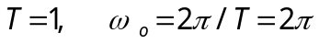

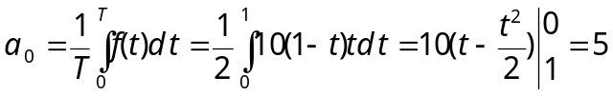

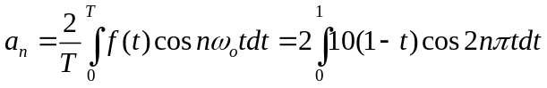

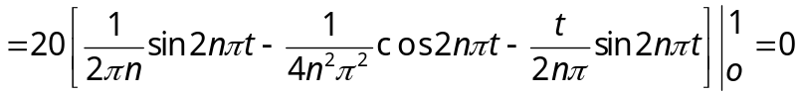

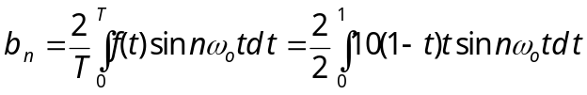

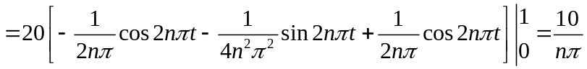

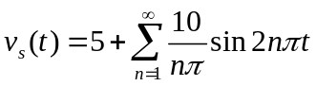
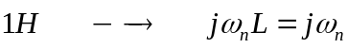
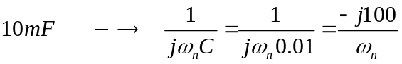

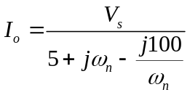

For dc component, ω₀ = 0 which leads to I₀ = 0.

For the nth harmonic,

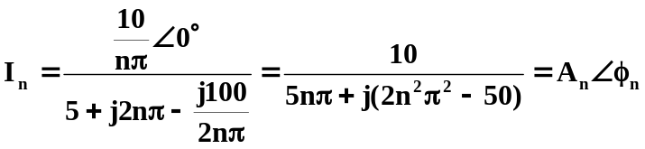

where
